March Newsletter
New Dawn CHS II
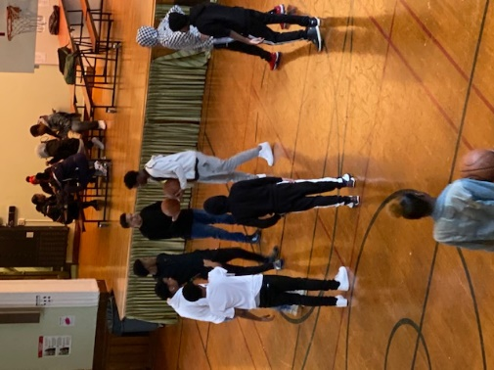

Upcoming Events

March 2
Regents Ready Parent Meetings Please RSVP for 8 am or 4pm
March 10
Important NYSED Graduation requirement meeting
March 13
Field trip to the Opera!
Early dismissal (2 pm): Professional Development off-site.
March 19
Students virtually participate in the ICEQ2020 Conference in ASL
March 27th
Third marking period ends

Important Announcement
ALL STUDENTS ARE EXPECTED TO TURN IN THEIR CELL PHONES. Any student that does not turn in their cell phone will be sent home. Please help us maintain this policy, it is mandatory for continued enrollment at the school.

89-25 161st Street Jamaica, NY 11432
www.ndchsqueens.org T: 347-947-2580
Dear Parents/Guardians,
March is going to be a very busy month for our staff and our students. There are a lot of very exciting things happening!
First and foremost, I want to reiterate the message that was sent home with your students on Friday, February 28th from the NYC DOE: we cannot panic about the coronavirus. At this time, there are no known cases of coronavirus in NYC. We plan on operating business as usual, unless otherwise directed by the Health Department. For now, please continue to practice good health. Stay home when you’re sick, wash your hands with soap, sneeze into your arm, and remain calm. We will of course update you regularly if anything changes.
On Monday, March 2nd, I will be hosting parent meetings to discuss what it means to be “Regents Ready.” This is a very important semester for your students. Now that they have met with me and their mentors regarding their projected graduation dates, they must work to maintain and reach that projection. Passing their classes with college and career level readiness is part of that preparation. Please attend the 8 am or 4 pm meeting on Monday for more details. I look forward to seeing you!
This month we are working hard to connect your students to the city. In the coming weeks your student may be invited to attend different field trips that connect what they are learning to experiences at museums, and performances. Right now, a trip is planned with Mr. Pham’s class for March 5th, and on March 13th a select group will be attending a final dress rehearsal of the opera at the Met. For students to attend field trips, they must have good attendance, approaching college and career level standards, and good behavior. Students with multiple referrals for poor behaviors cannot go on trips at this time.
Please note on March 13th both New Dawn campuses will be attending PD off site, which includes touring our beautiful building construction on Hoyt Street. As a result, classes will be dismissed at 2:00 pm.
On March 19th, a small group of Ms. Silverstein’s ASL class have the honor of participating virtually in an international conference: ICEQ2020 (International Conference for Educational Equity). We are representing New Dawn both virtually and in person. Stay tuned for more details on this exciting endeavor!
On March 27th, the third marking period of the year will come to a close. This is an important indicator of your student’s college and career readiness. By April 17th, the first projection of Regents Readiness will be released. Stay tuned!
REMINDER:
The new door policy has been in effect. Students are required to be in school at 9 am. However, we have established a 9:30 am grace period. If your student is in after 9:30 they will receive a warning. After the SECOND WARNING, students will be sent home. This is vital to their academic performance. Many students are missing their morning credits because they are coming into school late. Please help them come on time and be ready for learning. This impacts their graduation date!!!
Your immunization records MUST be up to date. If you receive a warning letter, please know that we have no choice to send your student home if they are not current. It’s the law.
Additional Announcements:
Mr. Emrich has resigned his position from the school. We are in the process of identifying a new teacher and will introduce that person to you very soon. We wish Mr. Emrich the best!

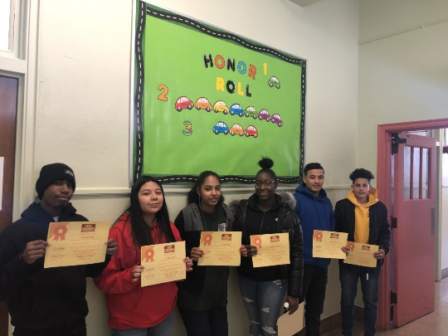
Congratulations to our honor students, second marking period!
FOLLOW US
on Social Media!

Twitter: @NewDawnII

Facebook: https://www.facebook.com/NDCHS2/

Instagram: https://www.instagram.com/ndcsqueens/

