January Newsletter
New Dawn CHS II
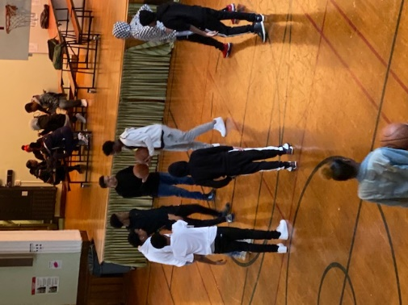

Upcoming Events

January 20
Schools Closed Martin Luther King, Jr.
January 21-24
FINAL EXAM Schedule- please look for the schedule in your email and from your student on Monday, January 6th
January 27
Schools CLOSED- Teacher Development Day
January 28
Spring Semester begins

Important Announcement
ALL STUDENTS ARE EXPECTED TO TURN IN THEIR CELL PHONES. Any student that does not turn in their cell phone will be sent home. Please help us maintain this policy, it is mandatory for continued enrollment at the school.

89-25 161st Street Jamaica, NY 11432
www.ndchsqueens.org T: 347-947-2580
Dear Parents/Guardians,
Happy New Year!
Your New Dawn II family sincerely wishes that you had a wonderful break and are ready to help your student to the finish line: final exams and credit accrual for the fall semester!
This is a very exciting time of year. Your students will get to the see the progress they have made with New Dawn as compared to their former schools and see what their projected graduation date will be.
The marking period will end on January 16th, with the Career Choices final happening in class on January 17th. The remainder of the finals will follow the testing schedule during the week of January 21st through the 24th. Please look for an email and a printed copy of the schedule on our website and with your student on Monday January 6th.
IMPORTANT NOTE: No work can be made up after January 15th. This is the close of the fall semester and credit accrual will be calculated. All work must be in before January 15th to be considered.
Some reminders:
The new door policy has been in effect. Students are required to be in school at 9 a.m. However, we have established a 9:30 a.m. grace period. If your student is in after 9:30 they will receive a warning. After the SECOND WARNING, students will be sent home. This is vital to their academic performance. Many students are missing their morning credits because they are coming in to school late. Please help them come on time and be ready for learning. This impacts their graduation date!!!
Your immunization records MUST be up to date. If you receive a warning letter, please know that we have no choice to send your student home if they are not current. It’s the law.
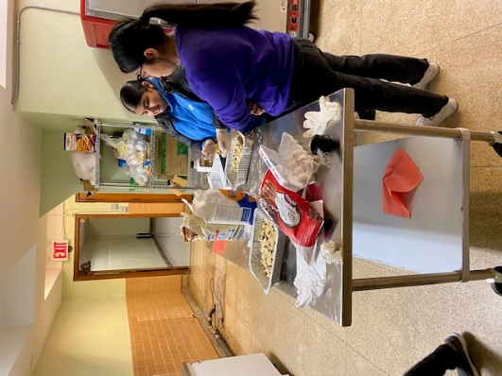

Cooking Club baking cookies!

More Important News
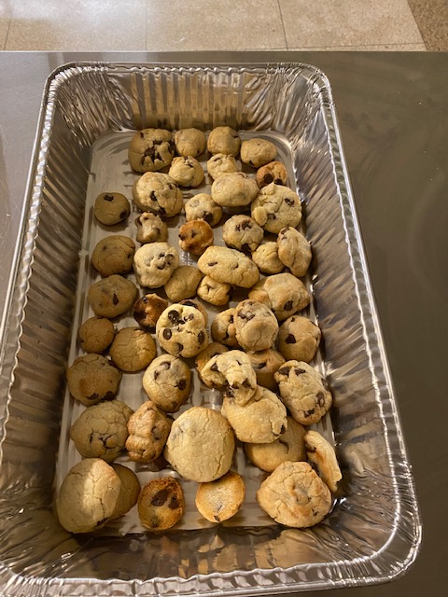
Jupiter
If you are interested in tracking your student’s progress - you can through our student information system! Please ask for a login from your student’s mentor. Ms. Francis, Ms. Spain, Mr. Flory, or any staff person can help you gain access right from your phone!

Enrollment Documents
It is essential for your formal enrollment to provide us all with all of the documentation for your student’s file:
- Proof of residence: This can be a utility bill (but not a cable bill), lease, HRA application, or any government-issued ID.
- Birth Certificate
- Enrollment Form packet
- Parent/Guardian Consent to Attend
- Free and Reduced Price Meals Application: This form must be completed for all students and will be held in strict confidence. Students will NOT get their MetroCard unless this application is completed.
- Immunization Records NO STUDENT WILL BE ADMITTED WITHOUT A CURRENT IMMUNIZATION RECORD. NO EXCEPTIONS.
- Medical Forms: This set of forms must be submitted for all students within the first 30 days of attendance.
- Record Release: This form gives the school permission to obtain all records pertaining to a given student from his or her previous school.
- Transcripts from all schools attended prior to New Dawn II
- IEP or 504 Modifications (if applicable)

