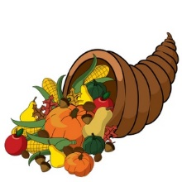
November Newsletter
New Dawn CHS II
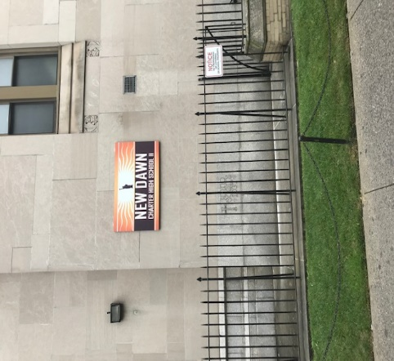

Upcoming Events

November 5
School Closed- Election Day
November 7
Open School Night/Parent Teacher Conferences – students dismissed at 12:30
November 11
Schools Closed - Veteran’s Day
November 27
Thanksgiving Dinner- students released early
November 28-29
Thanksgiving Recess

Important Announcements
- Students must turn in cell phones.
- Students MAY NOT wear bandanas. Du-rags in black or white ONLY are permitted.

89-25 161st Street Jamaica, NY 11432
www.ndchsqueens.org T: 347-947-2580
Dear Parents/Guardians,
I want to thank all of you for your support during this last week of October. We have worked very hard to build a safe learning environment, and this invasion from teens outside of the school is just unacceptable.
Moving forward, any student that flashes a flag, a hand sign, or yells any kind of gang expressions will be subject to the strictest of consequences in our school code. This school is a learning environment that prepares our students for college and career readiness, and this activity will not be tolerated. Considering the activity outside of the school, we are asking your help in working with your students to comply to these rules in our code.
For safety, we will release students early next week. I will email the times under advisement from the 103rd each day.
We appreciate your support!!
Other reminders:
The first marking is ending soon! All missing work is due NOW.
Metrocards are distributed at 4 pm ONLY. Do not lose them!
Your immunization records MUST be up to date. If you receive a warning letter, please know that we have no choice to send your student home if they are not current. It’s the law.

Meet the Staff!
On November 7th we will host our first Open School Night/ Parent Teacher Conferences. The event will take place throughout the day, beginning at 12:30 pm and concluding at 6:30 pm. Coffee and light refreshments will be served in the cafeteria. Please come to check on your child’s progress and meet the fabulous staff! If you cannot make it, feel free to reach out to me and schedule a call or an appointment. Remember, you can check your child’s grades and attendance ANY TIME through our Jupiter app. Access is free! As a reminder, my email address is ldigaudio@ndchsqueens.org. I respond as quickly as I can.

More Important News
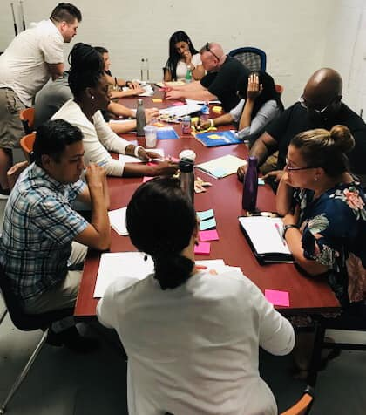

In the Community

Build the Block- Sector A Jamaica
November 14th 6:30 pm
Queens Public Library - Central Branch
89-11 Merrick Boulevard
Jamaica, NY 11432

South Jamaica Community Center
Events TBA

Thanksgiving
On Wednesday, November 27th, New Dawn II will celebrate Thanksgiving with students and staff. A full turkey dinner will be served. Early dismissal will take place after our dinner. Parent volunteers would be welcome to help serve!

Student Behaviors
Now that we are getting to know each other better, personalities are coming out and conflicts arise. Please encourage your child to follow our school rules and procedures. Here are a few reminders:
- Student entry is no later than 9:30. Mr. Flory has been letting students enter the building after that, but keep in mind that entry that late guarantees your child will be failing 1st period, which delays their progress to their diploma.
- We expect all students to follow the Three R’s: Respect, Responsibility and Resilience. Our NDII family deeply respects each of your children and we expect that in return. Disrespect towards staff and peers is completely unacceptable and will be dealt with in a severe manner. We just cannot allow students to break the peace in our community. We are on a mission!
Jupiter
If you are interested in tracking your student’s progress as mentioned above- you can through our student information system! Please ask for a login from your student’s mentor. Ms. Francis, Ms. Spain, Mr. Flory, or any staff person can help you gain access right from your phone!

